

LOGBOOK
Name of the trainer
Organisation

Introduction
The logbook is intended to support trainers in order to plan a Game of Change and will also be a basis for the evaluation process within our project.
It contains templates for:
- the planning of your Game of Change
- an overview of your performed Game of Change
- the collection of questions for the Coaching and Peer learning process
and a summary of all the key aspects for designing a Game of Change called “Essentials”

Content
- Template Planning your Game of Change
- Template Overview over your performed Game of Change
- Collection of questions for the Coaching and the Peer learning process
- Game of Change “Essentials”
  - Theory U
  - Info about Card Set
  - Formats of Strategic Staging
  - Game of Change steps
  - Life Comp Competences

Template Planning your Game of Change
Phase in the game | Step in the game | What methods/ exercises are used | Which LifeComp Competences are promoted
Preparing for  the game | Planning the best fitting format
Preparing for  the game | Preparing the space
Preparing for  the game | Preparing the materials
Arrival and introduction to  the game | How to explain the game to the participants
Arrival and introduction to  the game | Defining a common topic
Getting into the game | The strategic staging comes into play
Getting into the game | The players get into their role characters
Getting into the game | Accompanying the players into the role
During the game | Keeping the game going
During the game | Critical stages in the process and how to overcome them
After the game | Exiting the role
After the game | Reflexion on the process
After the game | Transfer

Template Overview over your performed Game of Change
Location
Date
Duration in hours
Number Participants
Profile Participants
Short description e.g.: age, professional background (student university, student in adult/vocational education, skilled worker, unskilled worker, employee, self employed,....), if applicable: which vulnerable group (long-term unemployed, seniors, single parents, persons with disabilities, migration background, lack of education, drug abuse,…)
Description of the Game
Brief overview of the individual steps and the process
Common Topic
Format of Staging
Title of Staging
Short Feedback Participants
If there are more meetings: short, informal feedback. If there is just one meeting use the questionnaire for participants

What went easily and what was more difficult?
What do I assume about why the easy was easy and the difficult was difficult?
How did I feel in the role of a trainer providing the qualities of an open heart/mind/will and at the same time holding clear structures and frameworks?
On a scale of 1 to 10 (1 little, 10 a lot), how many stars do  I give myself as a trainer for facilitating this session? |  | ✩ ✩ ✩ ✩ ✩ ✩ ✩ ✩ ✩ ✩
My Takeaways

Collection of questions for the Coaching and the Peer learning process
Questions/Input for Coaching:

Questions/Input for Peer Learning:

Game of Change “Essentials”
On the following pages you will find the essentials of the conceptual pillars and steps:
- Theory U
- Info about Card Set
- Formats of Strategic Staging
- Game of Change steps
- Life Comp Competences

Theory U

Process steps for change
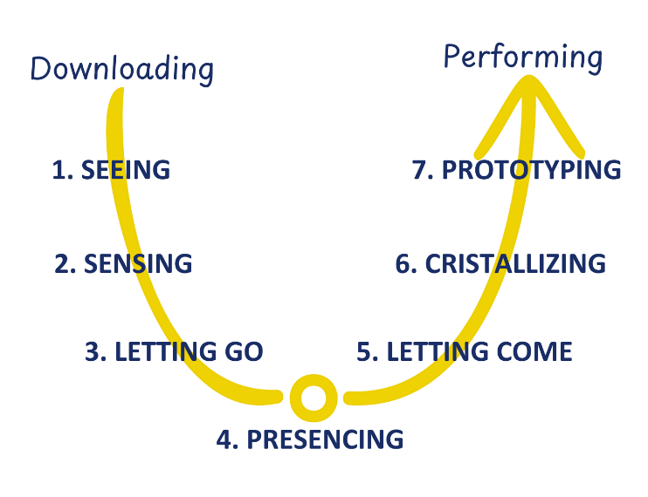

Inner attitude for transformative changes and weakening voices
Open Mind - Voice of Judgment
Open Heart - Voice of Cynicism
Open Will - Voice of Fear

The four levels of listening
Level 1: Downloading
Level 2: Factual Listening
Level 3: Empathic Listening
Level 4: Generative Listening

4. GENERATIVE LISTENING
1.DOWN-LOADING
2. FACTUAL LISTENING
3. EMPATHIC LISTENING
Open Mind
Open Heart
Open Will

The Game of Change Card Set
26 Role Cards
26 Principle Cards
26 Action Cards


Each card provides a drawn picture and inspirational texts and/or questions.

Strategic Stagings

Formats for Strategic Stagings
Social Formats¢¢
- Competitions, Sports Events
- Cultural Festivals
- Parades, Processions
- (State) Ceremonies
Other Formats
- Rituals
- Fairy tale, Heroic Epic
- Scientific exploration and Expeditions
- Attack

Game of Change steps

Preparing for the game
- Planning the best fitting format
- Preparing the space
- Preparing the materials

Arrival and introduction to the game
- How to explain the game to the participants
- Defining a common topic

Getting into the game
- The strategic staging comes into play
- The players get into their role characters
- Accompanying the players into the role

During the game
- Keeping the game going
- Critical stages in the process and how to overcome them

After the game
- Exiting the role
- Reflexion on the process
- Transfer

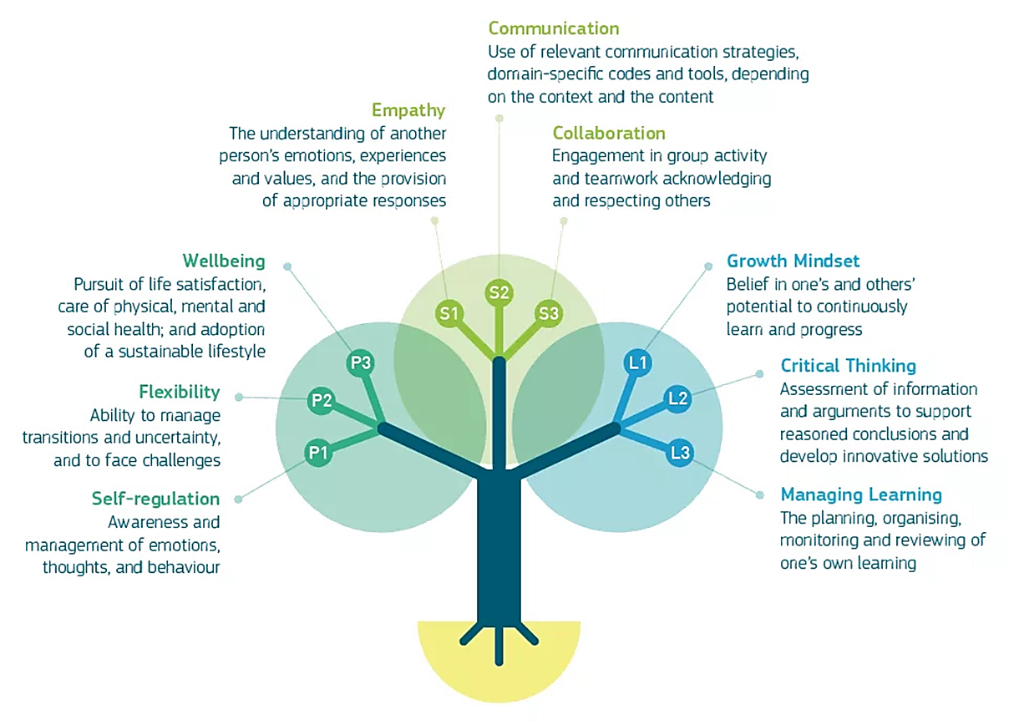
LifeComp Competences

